2016 and 2020 Presidential Election

Data Analytical Report

By

Richard (Kyaw) Paing

November 2, 2020

1a. 2016 polls

Clinton won in Minnesota by 8.277862%.

Trump won in North Carolina by 1.727367%.

Trump won Florida by 0.6718245%.

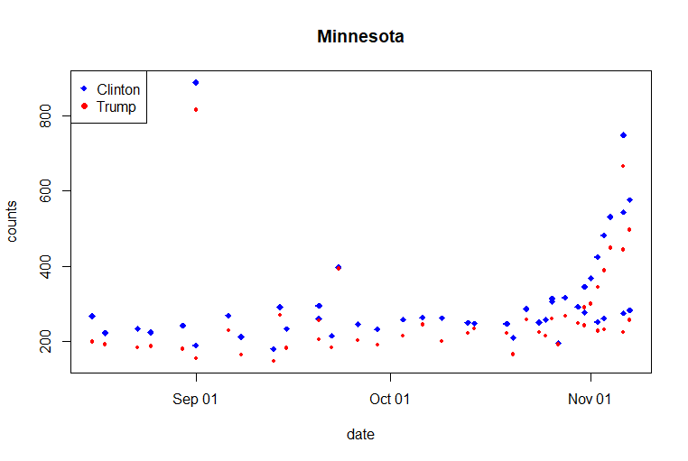1b.

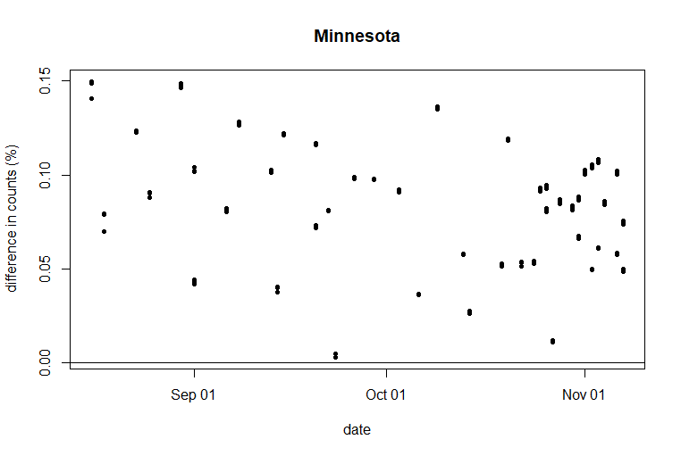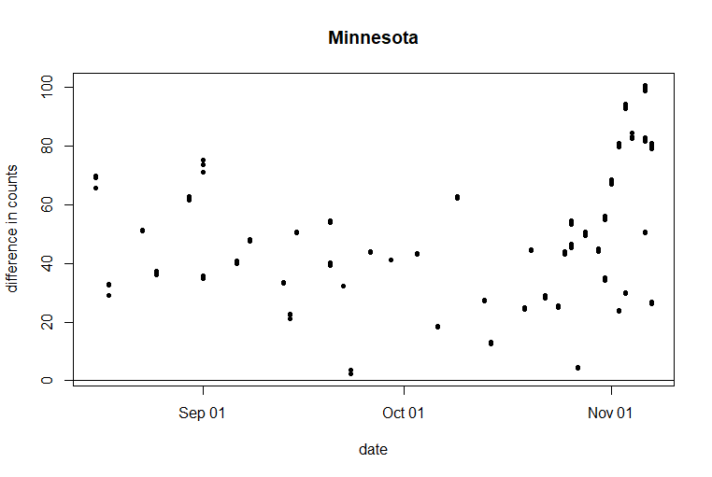

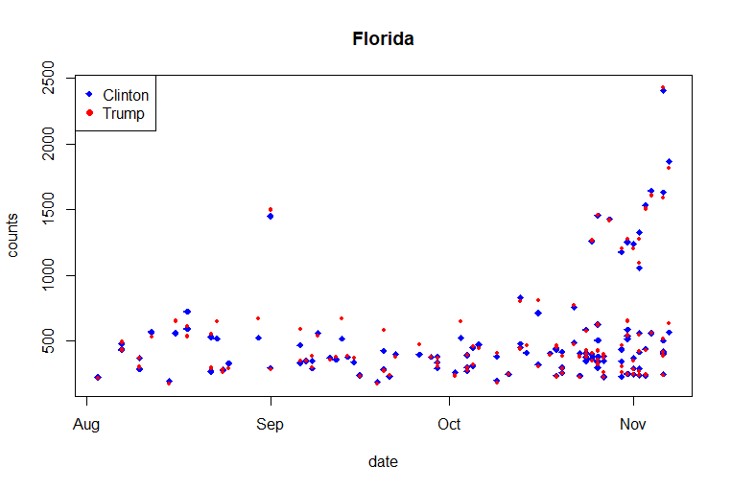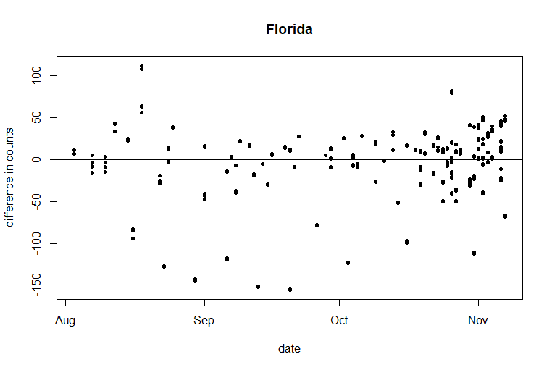

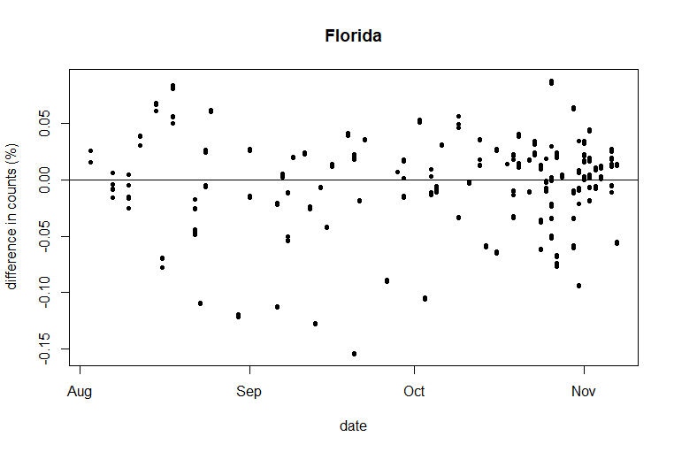

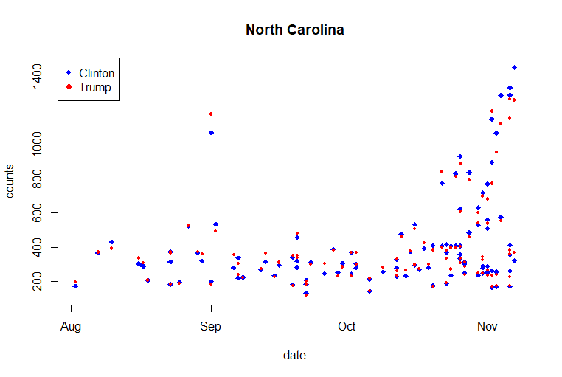

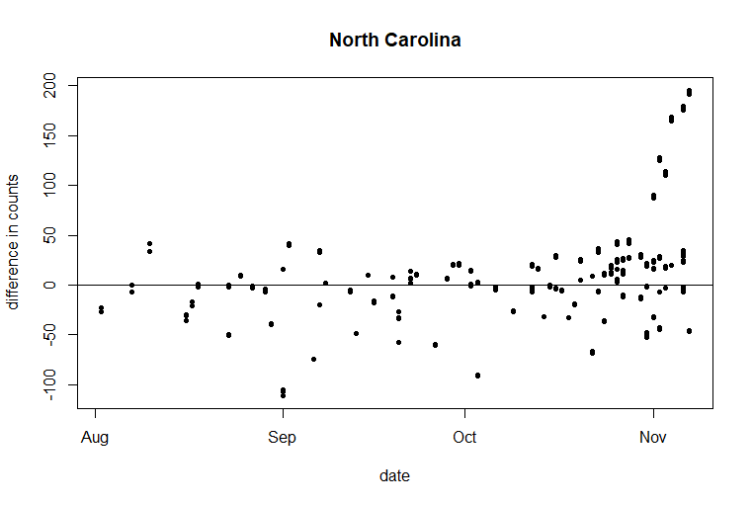

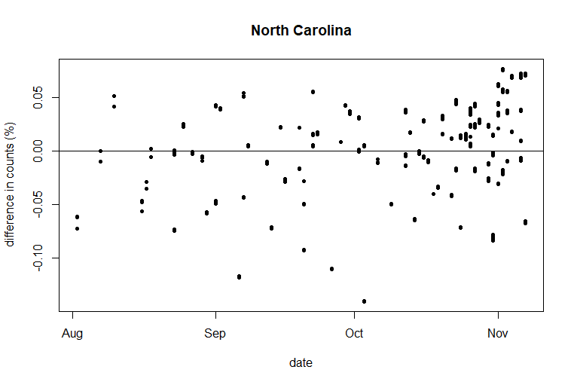

The plots show that Minnesota would vote democrat with a very large margin. North Carolina is going towards democrat, but since it is starting from a more republican side, it is not clear which candidate they will vote for. Florida seems to have relatively equal distribution between the parties but starts to go towards democrats slightly nearing the election day. It is still very equal for them and could go either way according to the polls.

1c.

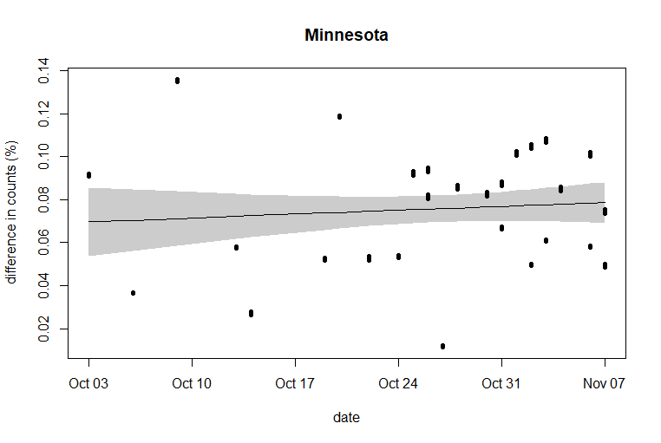

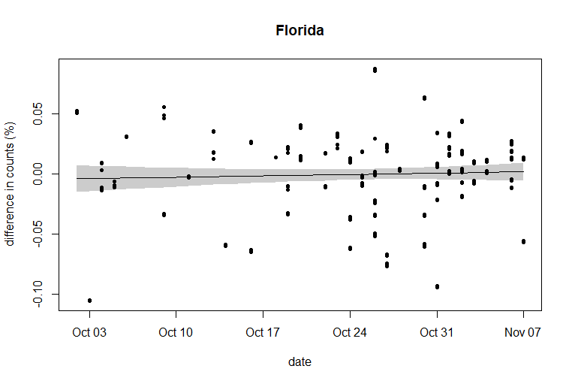

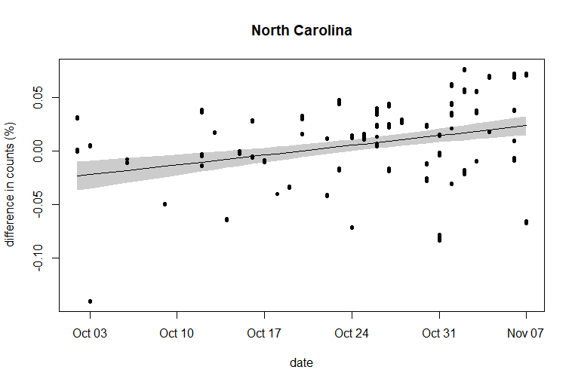

From the graphs the state with the smallest margin would be North Carolina and Minnesota would have the largest margin.

1d.

Florida had the smallest margin out of the three in the actual results (1.2 margin when searched up on wiki). Trump had appealed to working-class voters which may have really helped him out in winning this state. Florida did vote for Democrats in the previous election but with scandals and rumors about Hillary Clinton's emails might have changed their favor a bit. There is a high mistrust of politicians during the election.

What I found interesting is Minnesota though. Its polls give a relatively large margin in favor of Clinton, but the real results had a very tiny margin. This indicates that there is some bias in the polls in terms of who were surveyed. Many that were surveyed were college educated people through online polls, which will probably result in a lot more democrats responding to the polls than republicans and not representing the actual data. This ignored a lot of other voters who have heavily affected the outcome.

Neither candidate was popular either, leading many to become undecided as to who to vote for. This may have affected their response to the polls by supporting one person in the polls and voting for the other candidate. They also may not have voted at all, supporting neither candidate. Perhaps conducting polls on the same people nearing the election day would have produced different results.

2a.

Biden is leading Minnesota by 12.39751%, Florida by 1.465252%, and North Carolina by 5682513%. It seems that democrats are far in the lead for this election’s polls.

2b.

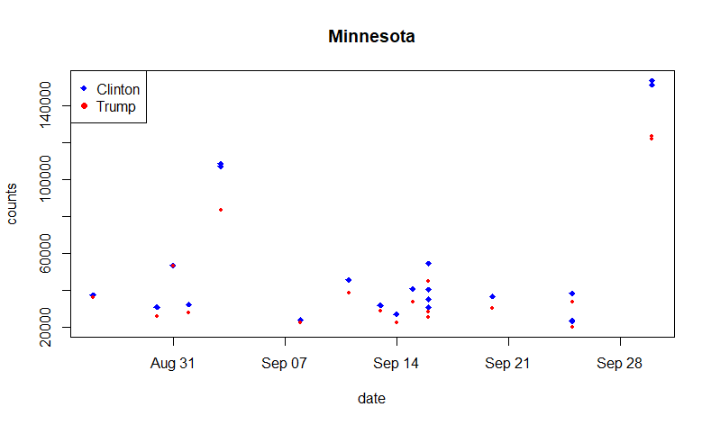

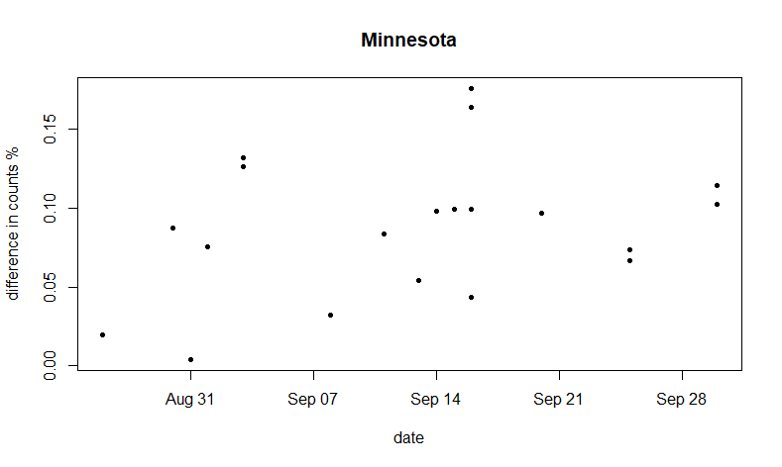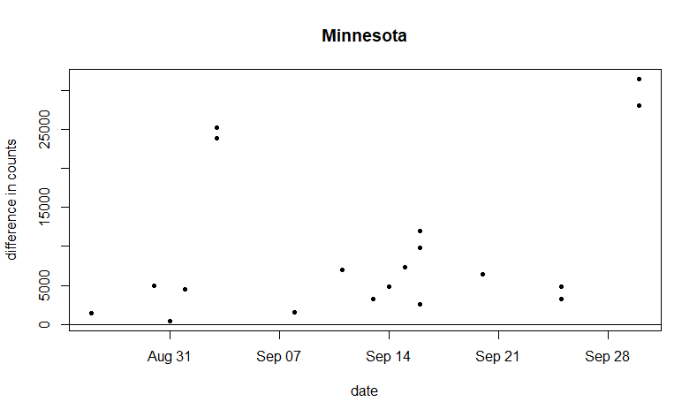

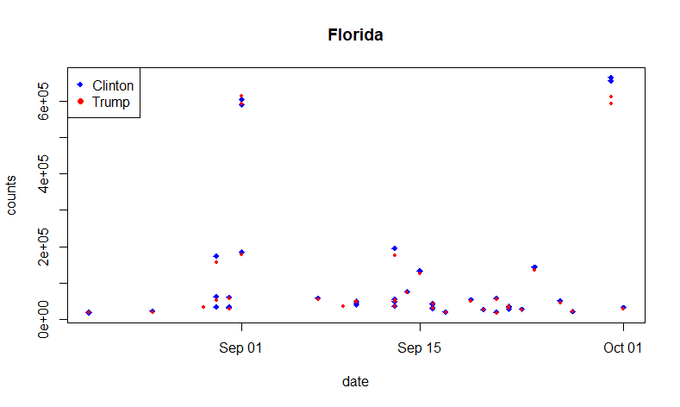

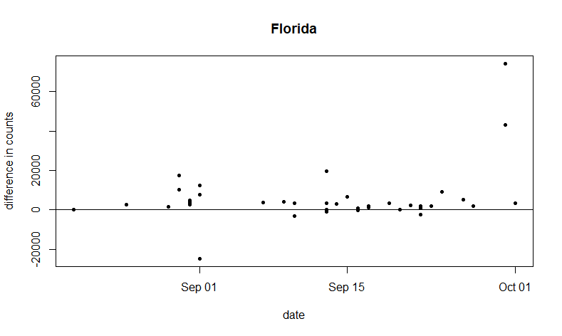

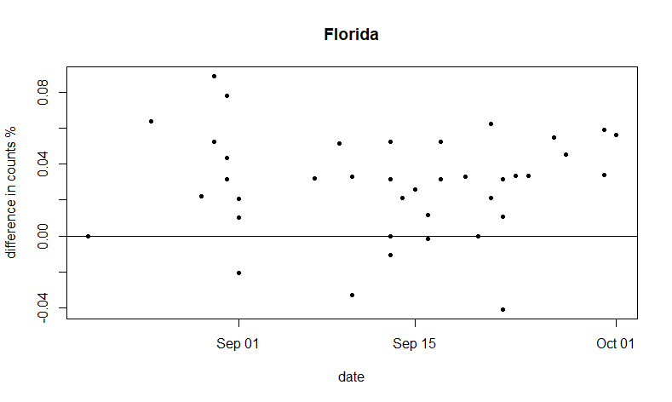

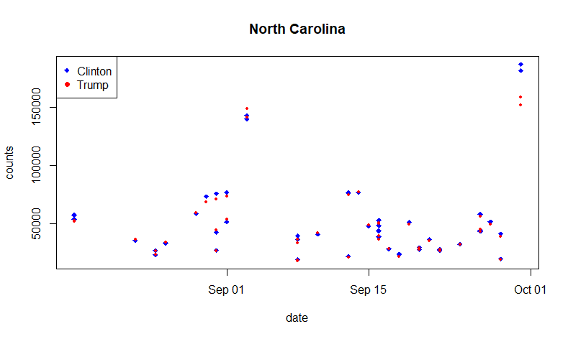

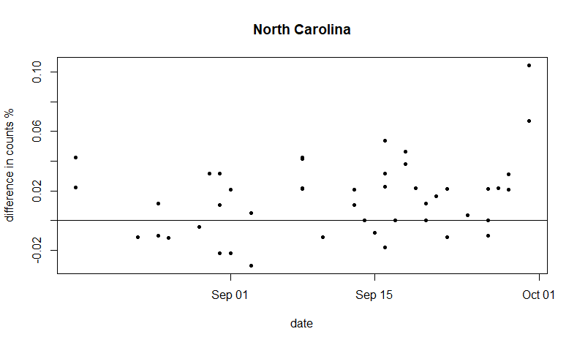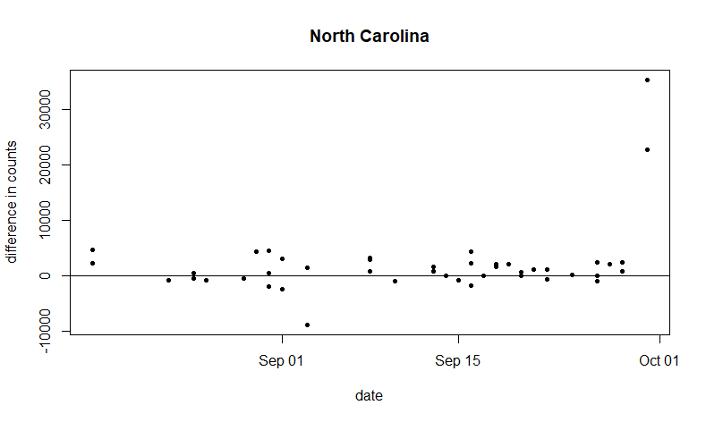

Overall, it is favoring the democratic candidate very much this election. It seems like there is no contest for Minnesota and it is going to go democratic. A lot of the poll difference in Florida is either at 0 or above it, meaning that the democratic party has a chance there. The same can be said for North Carolina, in that it favors the democrats, but is in more of a tie than Florida.

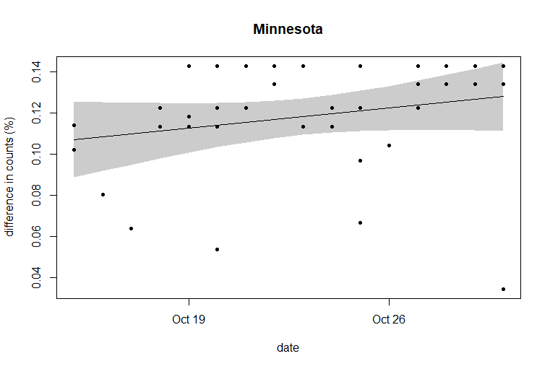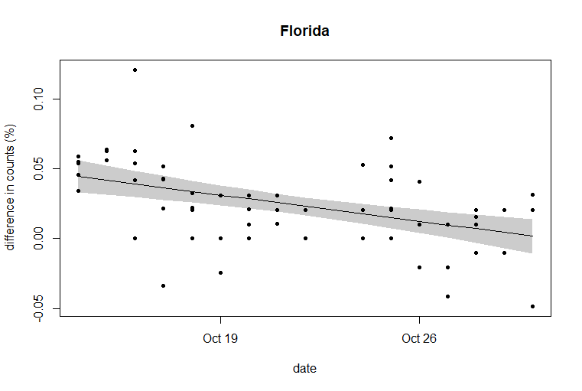2c.

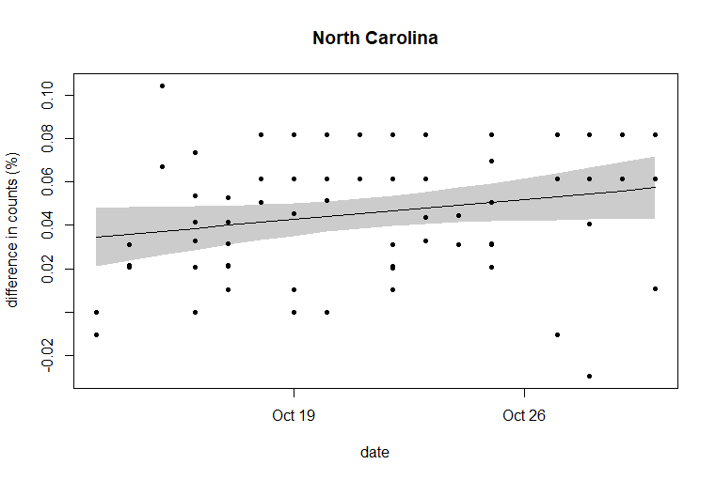

As I have seen in the scatter plots, most of the states are leaning towards democratic party, with North Carolina having the smallest margin out of the three states. Many of these polls can have a similar bias to 2016. Many polls are still asked online, however because of the pandemic, it can be argued that more republicans will also be spending more time on the internet which may have helped eliminate the bias. Florida seems to be heading towards voting for the republican party in starting from September 26.

3.

Both elections had a trend that was going to be in favor of democrats if it continued, especially for Minnesota and North Carolina. Minnesota also had a very large margin on both election polls. Florida and North Carolina had relatively smaller margins. What is different is that the polls seem to be really favoring democrats on the 2020 election since they would start at 0 for the percentage difference (at August October 1) and then they would increase for Minnesota and North Carolina. Florida is also decreasing towards the republican side way more than in 2016.

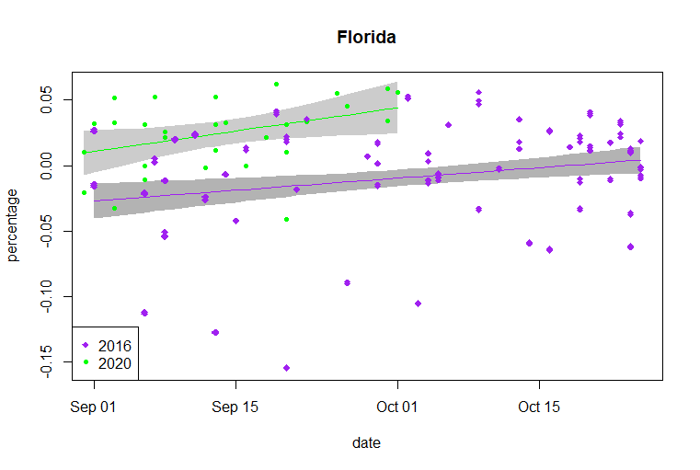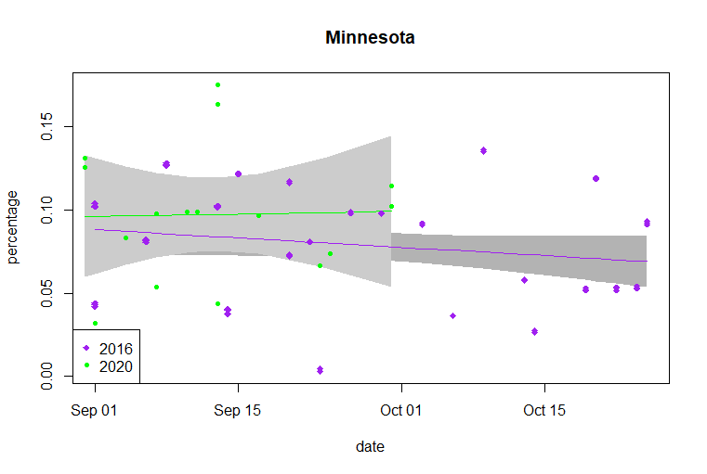4a.

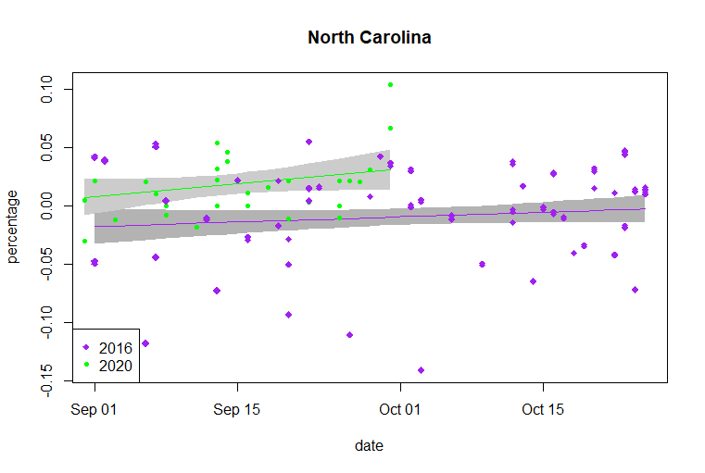

The difference of the polls plot make the US seem like a very democratic country overall. 2020 polls are a lot more in favor of democrats than the 2016 polls which even had a notable bias in that it surveyed a lot more democrats. It seems like in 2020 there is a much bigger difference in favor of democrats, while some red states are turning into battleground states.

4b.

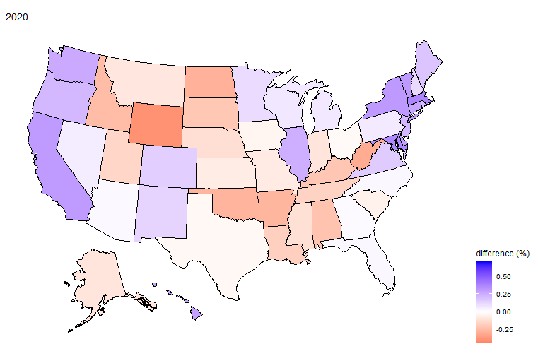

Ten battleground states may be Iowa, Florida, Texas, North Carolina, Florida, Ohio, Arizona, Arizona, Missouri, and Georgia. While on the plot these may look like battleground states, it may be because of bias. Some of the states in the middle used to always be republican, yet it shows up as a battle ground state, such as Texas. Several states that seem to have voted for the republican candidate have became battle ground states, which may be because of Covid-19. People may be unhappy with how largely Covid-19 has affect the U.S. and are perhaps unhappy with how President Trump has handled the situation. Also, many people have left California this year and moved to other states which may affect the polls.

4c.

Minnesota’s trend in 2020 seems just like a straight line, but it is going upward a little bit compared to 2016, which is clearly slowly going toward the republican side. The margin for 2020 is also very large compared to 2016. Because 2016’s polls in Minnesota looked like that and still went to Clinton, it is safe to assume that Minnesota will be democratic this election too. Both election polls in Florida has a positive trend being in favor of democrats, however the republicans won this in 2016. This year, it seems that democrats will win the state because of the large margin and its steeper positive trend. North Carolina is like Florida in that they both seem to be favoring democrats but was still won by republicans. The polls seem to be more in favor of democrats than the last election

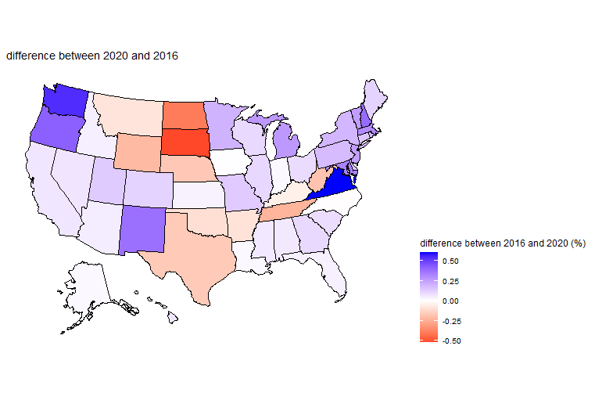

The US overall, just seem to have a lot more democratic states this year because some states in the middle are turning blue or are battleground states while the east and west have even stronger democratic presence.

4d.

Implement more different ways to survey people. A lot of polls are still done online in this election, which is more likely to attract democrats. A large portion of elderly are republican who may not spend too much time on the internet, causing the polls to have a bias for democrats.

Have a larger sample size by distributing the polls in many different counties or different parts of the state. This should be done in conjunction with the previous method, surveying online may be targeting certain counties or areas where people spend a lot of time on the internet, ignoring a large portion of people in other places.

5. Texas seems to have become a battleground state making it look white in the 2020 election poll map. A reason for this is that a lot of Californians have moved over to Texas due to high taxes and an unfavorable quality of life. Because California is a very democratic state, the people who move from California will affect the results of the 2020 election in Texas.

Wisconsin seems to be a state that may change its electoral candidate. Last election the Republican party won with a very small margin (0.77%). It may be that this election, the democrats will win. Looking at the US map of 2020 and 2016, the percentage difference looks almost the same, but it looks slightly bluer in this election. With Trump winning by a very small margin last election and the percentage difference looking bluer this election, it is very possible that Wisconsin will change.

North Carolina may also change their electoral vote to democrat. Like Wisconsin, this state also won by a relatively small margin. In the map it seems to be more slightly blue.

Arizona is more likely to change their candidate in 2020. Looking at the map it is in favor of the democratic party.

Pennsylvania also seems like a state that may change its candidate from the last election. In 2016 there was a rather clear downward trend in percentage, however during this year there is a somewhat increasing trend.

I think a lot of the reason for why these states may change their candidate is that they may not have been happy with the condition that the US is in right now and may be blaming President Trump for it. Some things like riots and the pandemic are very big influencers that may work against the Republican party, regardless of whether they caused it or not. Media portrayal of Trump has also been very negative which can be a factor in why some of these states will change to democrat.

6.

Iowa, Texas, Ohio, and Florida will probably vote Republican.

North Carolina, Nevada, Wisconsin, Arizona, Pennsylvania, Michigan, Minnesota, and Georgia will probably vote democrat. (only North Carolina was wrong)

I made my decisions based off the 2020 percent difference map, who the state voted on in 2016 and the linear models. I had also simply googled the state and how they were doing in polls (the first result gives data from <https://www.realclearpolitics.com/epolls/latest_polls/> ) However, most of the time, there were ties so I would have to check up on some of the states individually using RStudio. An example would be Georgia.

